Chapter 17-[Proof by Contradiction](https://mfleck.cs.illinois.edu/building-blocks/version-1.3/contradiction.pdf)

Monday, January 9, 2023

9:21 PM

***Proof by Contradiction:***

Prove that the negative of a statement is false, therefore implying that the statement is true.

Typically used to prove claims that a certain type of object **cannot** exist. The negation of the claim then says that an object of this sort **does** exist.

Simple Example:



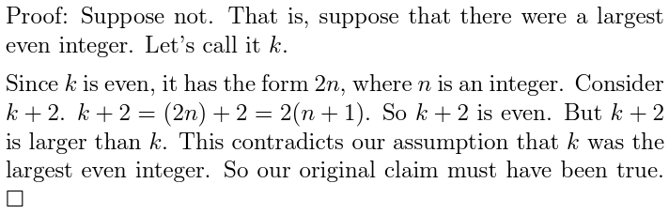

*(The phrase "suppose not" is a common indicator used to note the use of proof by contradiction)*

More Involved Example:

First, I can (but am too lazy to) prove the claim (*) if k is even, then k**2** is also even.

Now, Claim:



Proof:

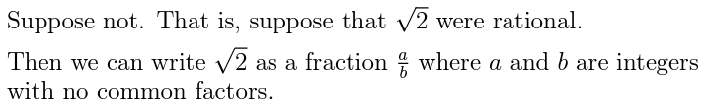

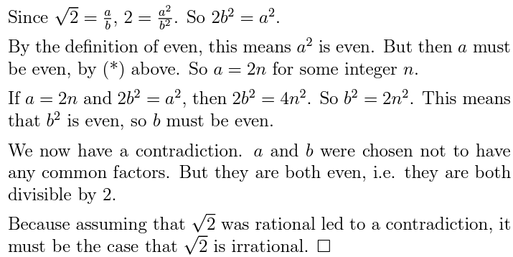

(Note that in proof by contradiction, we often don't prove specific claim true. Instead, we just prove a claim false, or reveal a contradiction that implies a claim false.)

***File Compression Example:***

In file compression, a ***lossless*** algorithm allows you to reconstruct the *original* file exactly from its compressed version;

But a ***lossy*** algorithm only allows you to reconstruct an *approximation* to the original file.



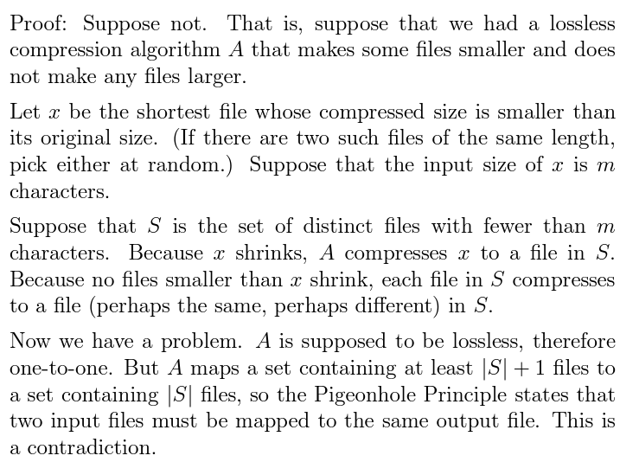

(basically saying that if the algorithm is lossless, it has to be one-to-one *(a)*. We feed the smallest file size that **can** shrink *(b)*, called *x*, into the algorithm, then some file with a smaller size, called *y*, has to be the output of *x*. But then if we feed *y* into the algorithm, it cannot be the output itself *(a)*, and cannot shrink *(b)*.

Therefore this is a contradiction)

*(so the lossless compression method is actually a lie! Sometimes the size gets bigger)*